IGR204 - M1 Project Description

Groupe M - TélécomParisTech, Mastère BGD
05/26/2018

Names of all project Members

Group M : Marine Ferrary - François Lecerf - Jérome Divac - Amaël Chaigneau - Christophe Thibault

Design document

In this project, the data available are related to first names given in France between 1900 and 2016. The data come from 2 different databases : The first one is based on first names in France, whereas the second one provides the first names for each department.

Our main idea is to get a feeling about the evolution of names through time, or compared to each other, or related to a specific department. This is why we would like to focus on 3 different types of design ideas.

- Comparison of frequency of names

The first design we suggest would display on the X-axis the time, and on the Y-axis the frequency of names. This would allow us to see the evolution of names through time, and see for example if a name becomes more popular or not. Ideally, it could be possible to select a few names, for example 5, for men, women or both, and plot simultaneously of the same graph the frequencies The advantage of such a graph is that it is easy to understand, but the drawback is that it is limited in terms of number of names we can select. Otherwise the graph loses its interpretability if too many lines are plotted at the same time.

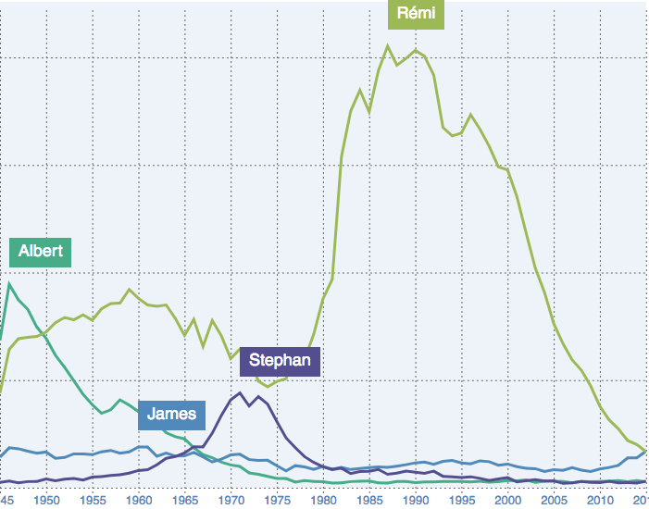

- Comparison of frequencies of names to each other

The second design idea we suggest is actually based on the a visual comparison of the names compared to each other. The way we think of this is as follows : for a given year, we would plot different bubbles worresponding to a name, where the size of the bubble would be proportional to the frequency of the name. The bigger the bubble, the more frequent is the name this year, and conversely the smaller the bubble, the less frequent is the name. We could add some parameters that we could select : for example, having the option of selecting only the top 100 names, or selecting only the names of men or women, or both… We could even imagine that when we move the mouse to a specific name, the actual number of names given this year would appear. The advantage we see in such a design is that it is visualy convenient to compare frequencies to each other. The drawback is that we lose the time dimension as we get only a snapshot for a given year.

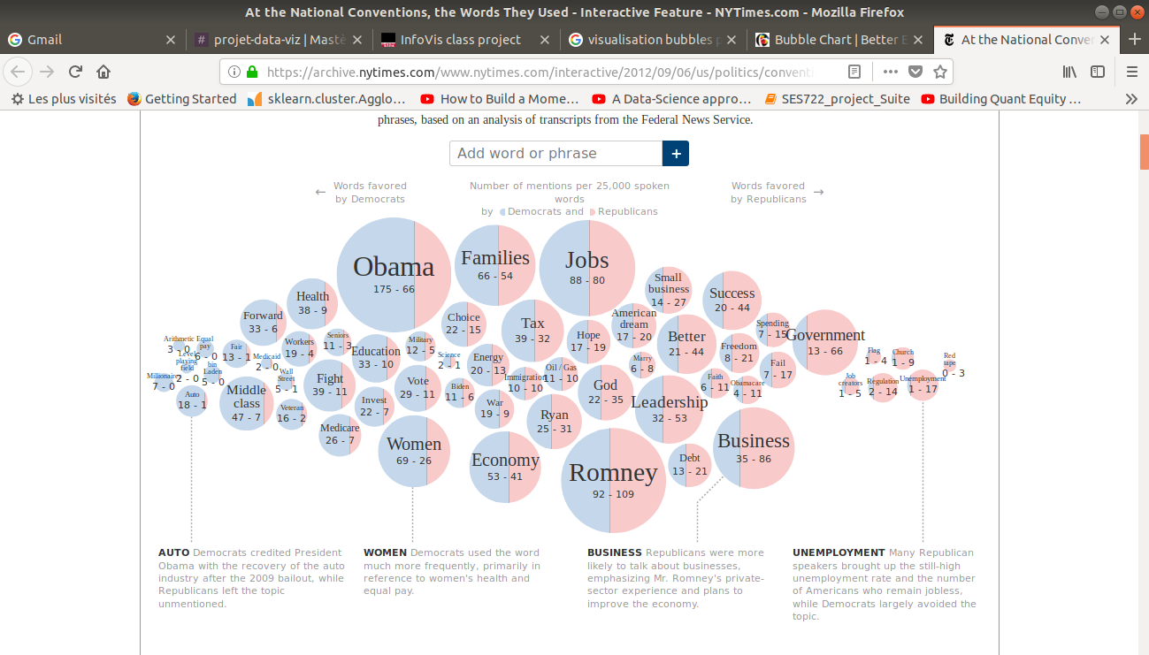

- Comparison of the names frequencies on the map of France

The final design we thought about is actually a map of France that would display for each department the top-K names given for a specific year. For example, when the user would move the mouse to a department, he could see appearing the names and their actual number for example. We could add some options to display different information, such as looking at only the names of men, or only women, or both. Or we could add a color to a name if for example it is growing in terms of popularity in a department compared to the previous year. The advantage of such a display is that is easy to understand, we could see if some names are more popular in some specific departments of France. The drawback is that it might have too much information if we display the names for all the departments available.

